***Demonstration of types of viruses and its mechanism***

1. Assignment of members

* We take the design concept of the game [Plague inc. Evolved](https://www.ndemiccreations.com/en/25-plague-inc-evolved).

Le Truong Giang 20194430:

* Intro : *
* Mainmenu : envelope screen, nonenvelope screen
* GeneralVirusController: *
* EbolaController: *
* NoroController: *
* HivController: *
* *CovidController: Video <Extend Part>*
* *RhinoController: Video <Extend Part>*
* *PolioController: Video <Extend Part>*
* *Note: the Video Part i followed the instructions in https://www.youtube.com/watch?v=ceXHH9sYIkk*

Nguyen Duc Phu :

1. Mini-project description

- Our project is demonstration of types of viruses and its mechanism. At this project we try to describe for users the structure and understand how the virus can infect the host cell. We try to achieve the aim of project in 3 step:

+ The first, we show the structure of virus, then users can distinguish different characteristics of viruses.

+ The second, we show the animation of the virus’s infecting to host cell process.

+ The third, we show the video describe lifecycle of virus, the users can deeply understand about the infecting mechanism of the different viruses.

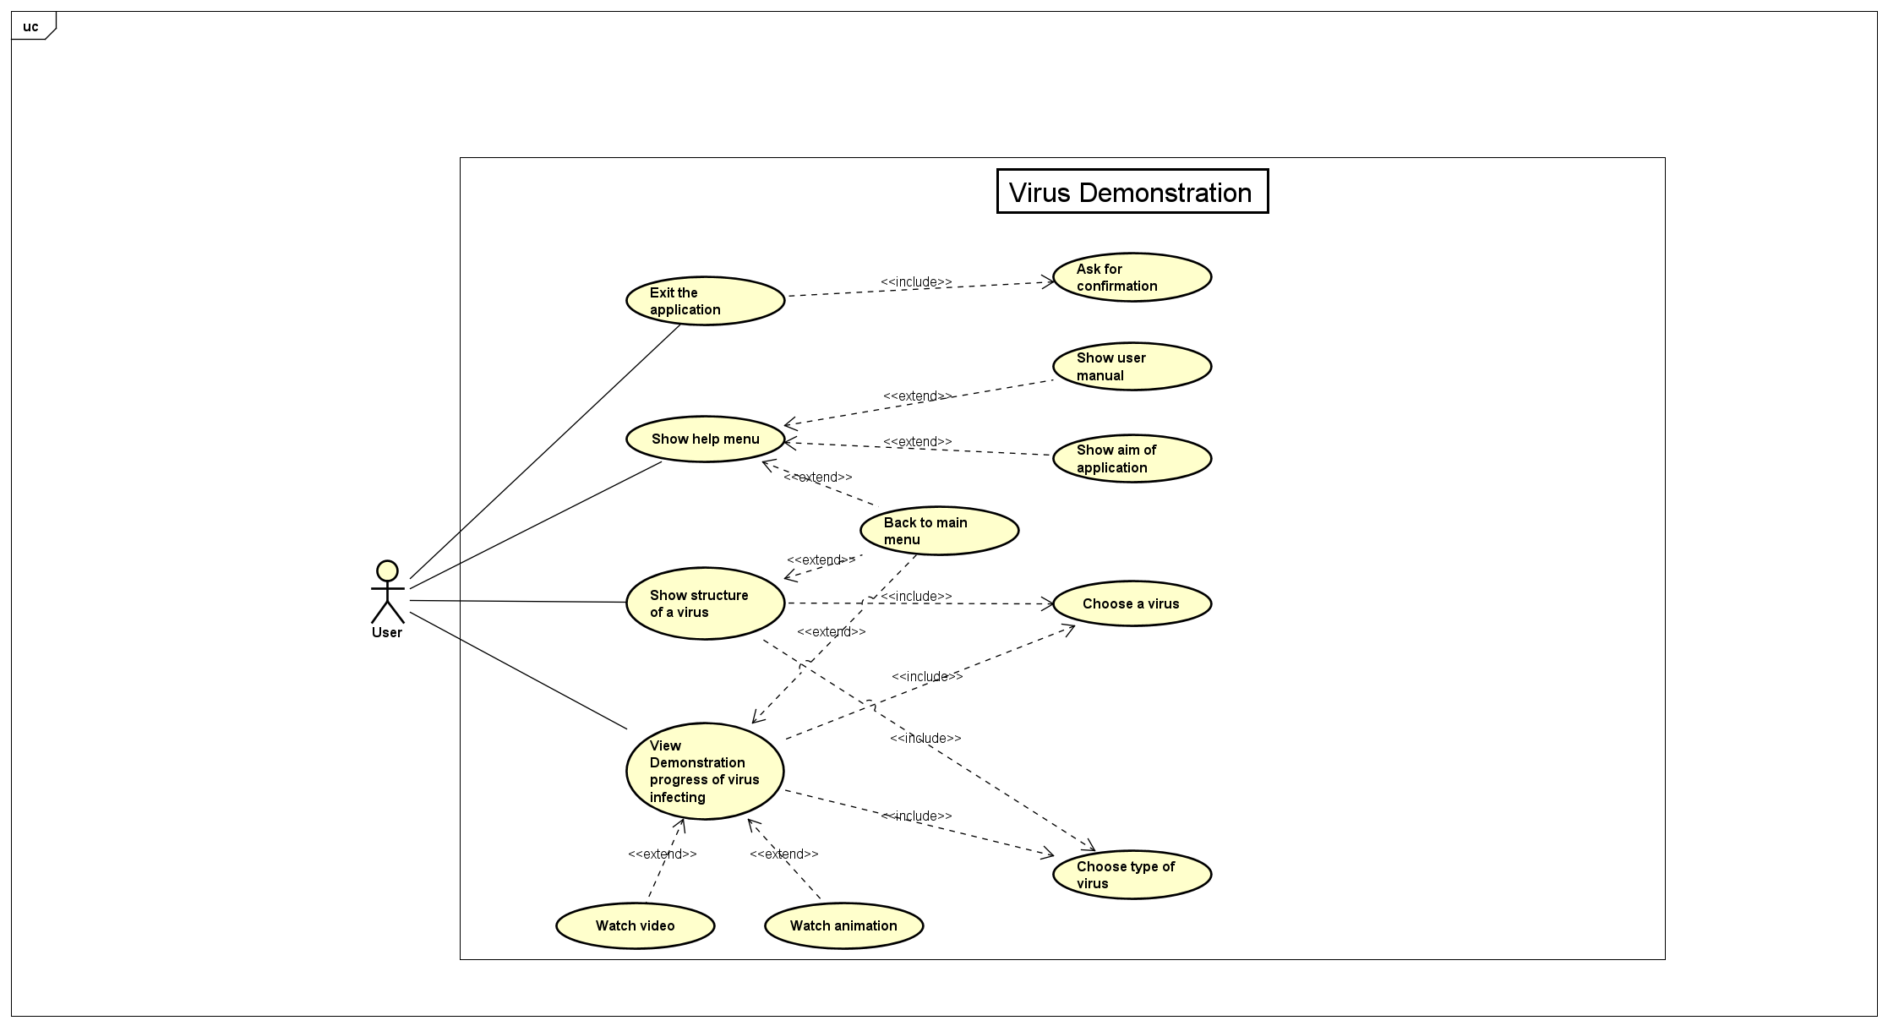

+ In the main menu, the users can choose 4 options :

* 1. Investigate Envelope Virus:

- Show the screen of list of envelope viruses with illustration. Here, users can select the specific one (CoronaVirus, EbolaVirus, HIV). After that, the screen of virus’s structure appears firstly. On the main screen, users can click on the name of virus’s part to see more detail. On the left handside, Users can open the navigate bar to choose other options (Animation, Video Demonstration, Back to main menu). At animation screen, users can play the process by click on “PLAY” button.

* 1. Investigate Nonenvelope Virus

- Show the screen of list of nonenvelope viruses with illustration. Here, users can select the specific one (RhinoVirus, NoroVirus, PolioVirus). After that, the screen of virus’s structure appears firstly. On the main screen, users can click on the name of virus’s part to see more detail. On the left handside, Users can open the navigate bar to choose other options (Animation, Video Demonstration, Back to main menu). At animation screen, users can play the process by click on “PLAY” button.

* 1. Show Help Menu

- Users can find more information about the application.

- Users can back to main menu by clicking on “X” button on the right-top corner.

* 1. Exit Application

- Show the alert confirm dialog.

1. Design

+ The general class diagram:

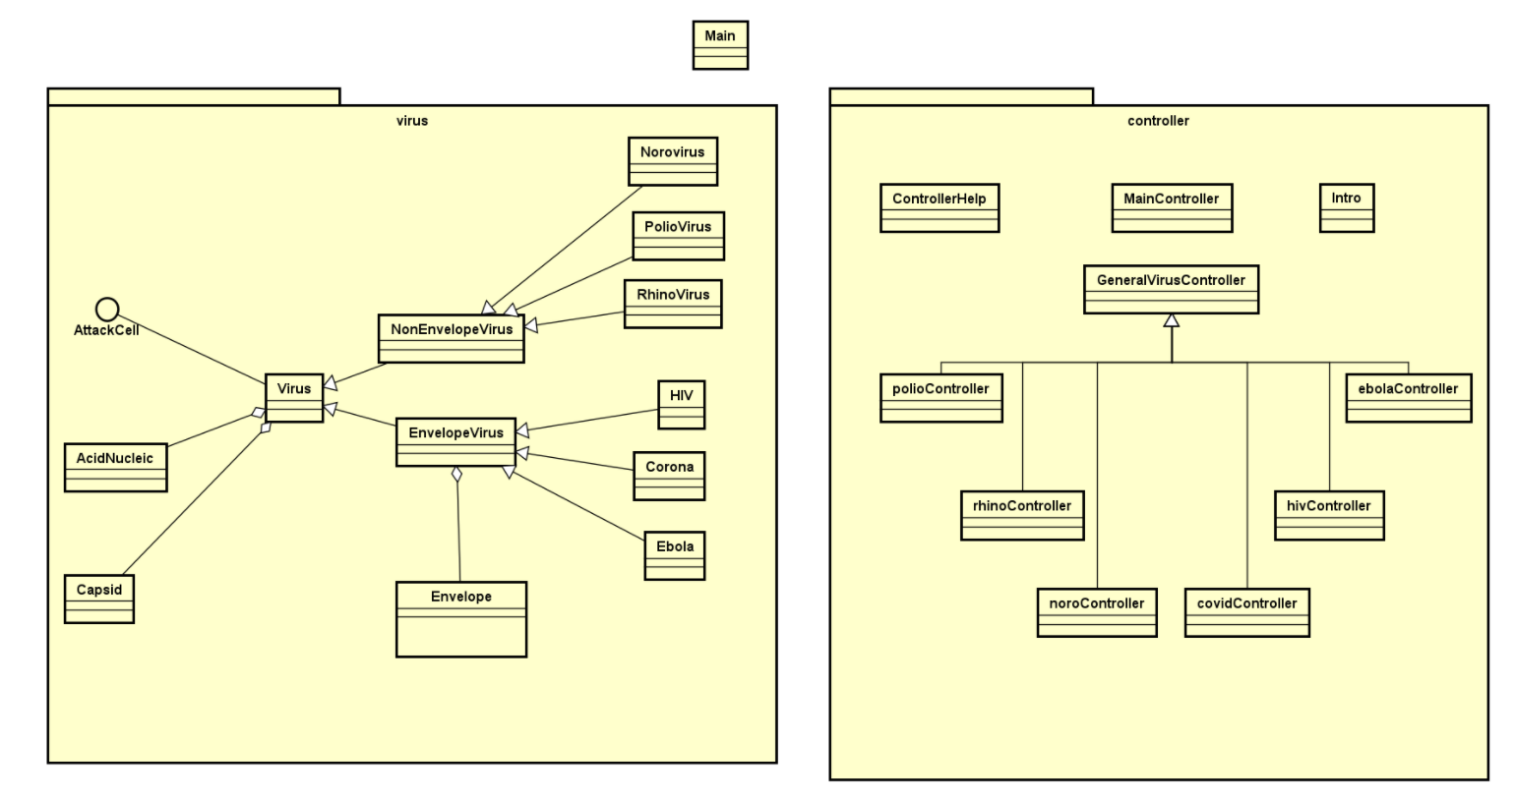

+ The detail class diagram of package Controller:

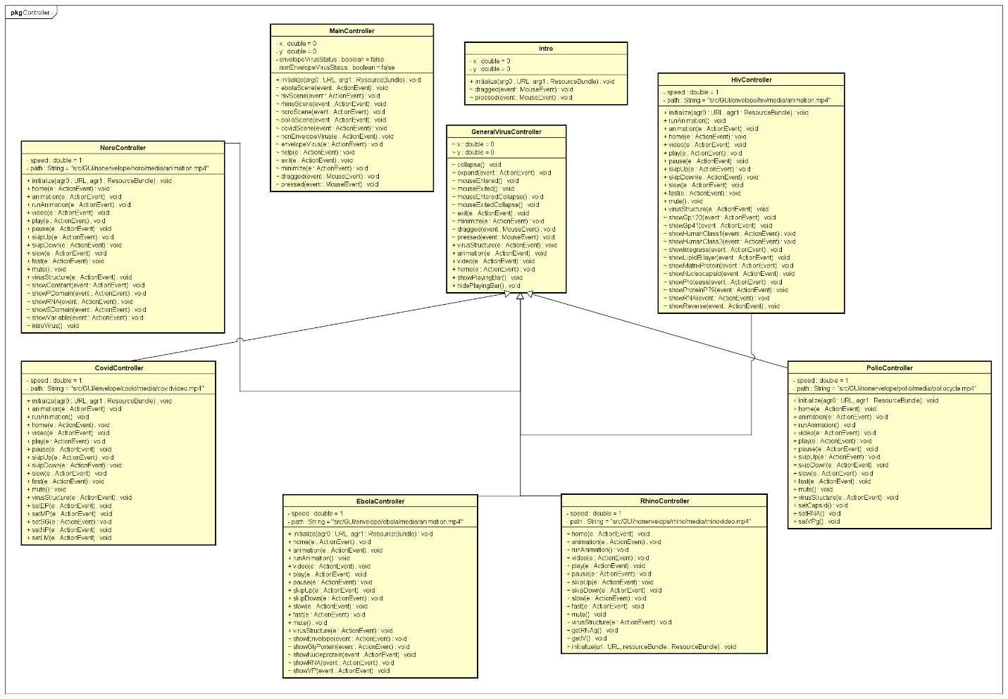

+ The detail class diagram of package Virus:

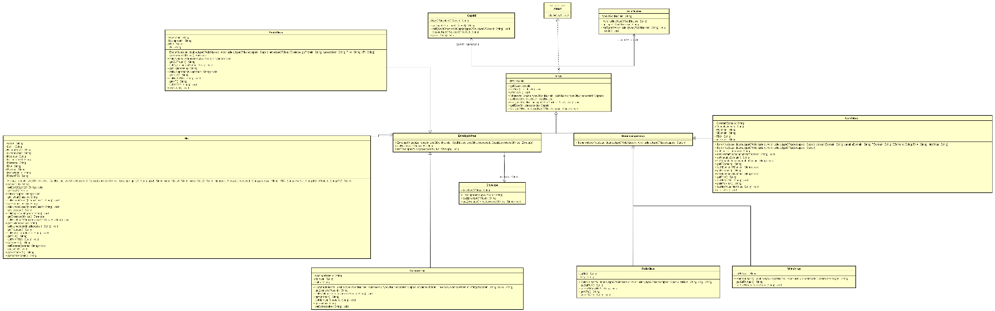

+ Every virus have acid nucleoic and capsid, so we create class **AcidNucleic** and class **Capsid** are 2 class composition for the class Virus. There are two type of virus : **EnvelopeVirus** and **NonenvelopeVirus**, then those types inherit from **Virus**.

+ All Envelope Virus have a viral envelope, then we create class **Envelope** which is composition for class **EnvelopeVirus**. **CoronaVirus**, **HIV**, **EbolaVirus** are envelope-virus, so they inherit from **EnvelopeVirus**.

+ **PolioVirus**, **NoroVirus**, **RhinoVirus** are nonenvelope- virus, so they inherit from **NonenvelopeVirus**.

+ About the class controller: **PolioController**, **CovidController**,**HivController, NoroController**, **RhinoController**,**EbolaController** inherit from **GeneralVirusController** for reusing the method

+ Some important methods:

- *runAnimation()* in all virus controller: to run infecting to host cell process (When users click on “PLAY” button).

- *virusStructure(ActionEvent e)* in class **GeneralVirusController**: to display the virus’s structure (When users click on “Structure” button at navigate bar).

- *video(ActionEvent e)* in class **GeneralVirusController**: to play a video about the virus (When users click on “Video” button at navigate bar).

*- help(ActionEvent e)* in class **MainMenu** to show help menu for users to find more information about the application.